Washington County Consolidated Communications Agency
Chief Executive Officers Board
Special
Meeting Minutes

January 29, 2026

In Person / Teams Video

Present Keith Mays, Board Chair, City of Sherwood, City Councilor
Jim Coleman, City of Hillsboro, Chief of Police
Erin Calvert, Assistant County Administrator, Washington County
Deric Weiss, TVF&R, Fire Chief
Ernie Happala, City of King City, Chief of Police

Guest Jennifer Schoorl, HR Answers
Laurie Grenya, HR Answers

Staff Present Mark Buchholz, Executive Director
Michael Stout, Chief Financial Officer
Kim Foster, Operations Manager
Jennifer Kilcoin, Human Resource Manager
Barbi Denman, Administrative Specialist

A. Call to Order
Chair Mays called the meeting to order at 1:02 pm

B. Roll Call

C. New Business
1. Salary Compensation Study for Executive Director position.
a. Review and analysis with contractor HR Answers.

Chair Mays introduced Jennifer Schoorl. Jennifer introduced the Owner/President of HR Answers, Laurie Grenya.

HR Answers was hired a year ago [to assist in a performance evaluation, and then expanded] to do a compensation study of the Executive Director position. Priority was to fully understand what a fair wage would look like.

Mays indicated that typically with this type of position, we are not hiring to a scale or range and there are no step increases. Schoorl reviewed the approach to the comp study that was done and how information was selected to be included. A published survey source was discussed. HR Answers uses Economic Research Institute (ERI) and CompAnalyst (11/2025), predominately because these two survey resources are very robust and validated. They are also updated regularly. Understanding the “scope” of the survey was also discussed. HR Answers pulls data from these sources, and it allows them to “scope” to a specific geographic area, to an industry, size of the organization, to pull relevant information.

Portland Oregon was used as the geographic scope for this study. Organizations within the industry and similar size were also looked at for an Executive Director position.

“GEO leveling” is used when any adjustments are made. No GEO leveling was done in WCCCA’s survey, because the data was scoped to the organization.

In addition, seven relatively local, comparative organizations were contacted for this study. Four of these organizations provided data which was used in the actual study provided. The fifth and sixth were not included, due to the size and level of decision making/authority was not similar to WCCCA. The seventh agency did not reply.

HR Answers was asked to do a direct local market survey as well as review published market data. This hybrid method provides a good competitive, valued decision. This helps look at the market value of the position. This can mean a wide spread in salary because there are transferable skills for this position.

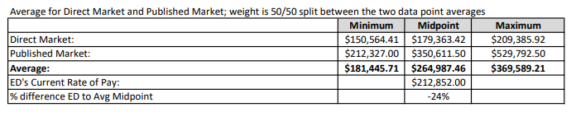
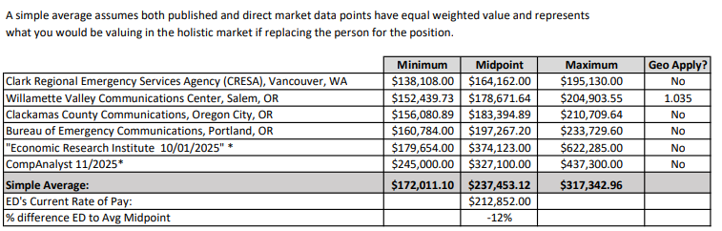

The Executive Director, was hired 4.5 years ago and placed at the top of the range. He has not received any market adjustments, except for yearly COLA’s during his tenure. To get to market, 12% is a large increase which was brought to the board.

Mays stated the Board could take the recommendations or choose to do something totally different. One scenario could be to take this back to December of 2024, with a target goal of $212k compensation today, but undo COLAs applied. HR Answers cautioned with reversing already applied COLAs.

Coleman commented that it seems clear that the ERI and CompAnalyst numbers skew the averages upwards from the direct comparators. Do we want to or don’t want to set the local market, but we want to be within a certain percentage of what the local highest compensation is? This would help WCCCA navigate when we have a dramatic difference like this. Is there a philosophy behind it?

Chair Mays reminded everyone that within the latest union negotiations, the goal was to compensate our represented employees fairly. Mays believes the philosophy should be higher than the comparators of Clark County, Willamette and Clackamas County, but maybe not to where Portland is.

Weiss said he is looking for a competitive salary without locking into a specific number, percentage or mandate. Keeping competitive ensures wages in the market if we have to replace the position.

Mays stated based on the Executive Director’s experience he was hired at the top of the range. If we had to replace the position, we should be somewhere in between Clackamas and Portland based on the salary data.

Discussion occurred about how the published salary survey numbers skewed the salary. HR answers explained that for some positions, public salary survey data makes sense for positions with transferable skills, like the Executive Director position.

Weiss wants staff to be paid above Clackamas. HR Answers recommends using the simple average model since it recognizes each market comparator as equal to the position.

HR Answers shared that the organization should define what is most important and what is valued by the organization and based on the job description, experience in 911 is valued. This is in line with the direct market comparators and in line with leading Clackamas and lagging behind Portland and capture that information.

Coleman is looking for a philosophy, like has been discussed here that shows a path forward, justifying any arguments, and consistent with those who are the organized rank and file. This drives home a sense of fairness and provides a roadmap for management.

Calvert proposed a 4% raise, back to January 1st, 2026. Coleman confirmed using the data provided by HR Answers and is happy that there is now a philosophy behind the data and to capture philosophy. Coleman believes the increase to be consistent and competitive.

Weiss suggested capturing that we will not exceed BOEC max wage and will not be below CCOM’s max wage. Coleman, Weiss and Happala agreed with proposed increase. HR Answers will capture the philosophy and an operational component to help measure.

Mays stated the proposed 4% increase with retro to January 1, 2026 will be presented with some narrative of the philosophy behind it, be brought to the next CEO.

D. Adjourn - The meeting was adjourned at 1:52 pm.

Next CEO meeting is February 19, 2026 at 1:30 pm.

